Circuit Analysis (Lab11)
Experiment 10: Verification of Norton’s Theorems

Name:Momna Ashraf Registration No: 2025-CE-72 Date: 18-05-2026 Grade and Signature: ……………………
CLO2 CLO3 | Use with identification the circuit components, breadboards, multimeter, power supplies, signal generators, and oscilloscopes. Make measurements in their own constructed electric circuits.
Psychomotor/Affective | Level1  (1) | Level2 (2-3) | Level3 (4-5) | Level4 (6-7)
Report Marks (3)
 | Total marks (10)

Objective
The objective of this lab is verify Nortan’s theorem and to find the full load current.

Apparatus Required
Sr. no | Apparatus | Range | Quantity
1 | Regulated Power Supply | Standard | 1
2 | Signal Generator | Standard | 1
3 | Oscilloscope | Standard | 1
4 | Digital Multimeter | Standard | 1
5 | Breadboard & Wires | Standard | As Required
6 | Resistors | 1k, 330 ohms | 1,3
7 | Potentiometer | Standard | 1
Description
Statement:
Any linear circuit can be simplified to an equivalent circuit consisting of a single current source and parallel resistance that is connected to a load.
Precautions:
- Voltage control knob of RPS should be kept at minimum position.
- Current control knob of RPS should be kept at maximum position

Procedure for Norton’s Theorem:
- Connections are given as per circuit diagram.
- Set a particular value in RPS and note down the ammeter readings in the original circuit.
To Find I_{N}:
- Remove the load resistance and short circuit the terminals.
- For the same RPS voltage note down the ammeter readings.
To Find R_{N}:
- Remove RPS and short circuit the terminal and remove the load and note down the resistance across the two terminals.
Equivalent Circuit:
- Set IN and RN and note down the ammeter readings.
- Verify Norton’s theorem.
To find load current in circuit 1:
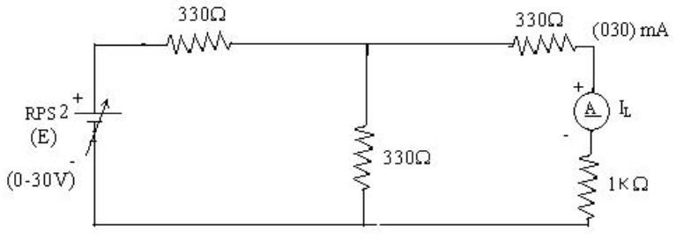
To find I_{N}
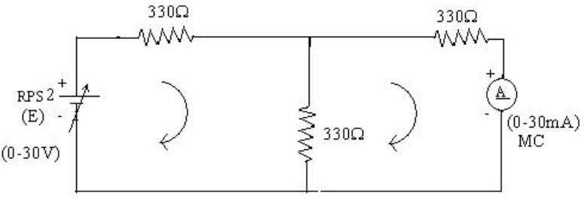

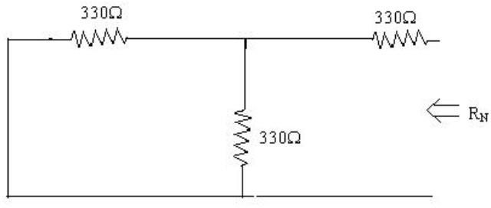
To find R_{N}

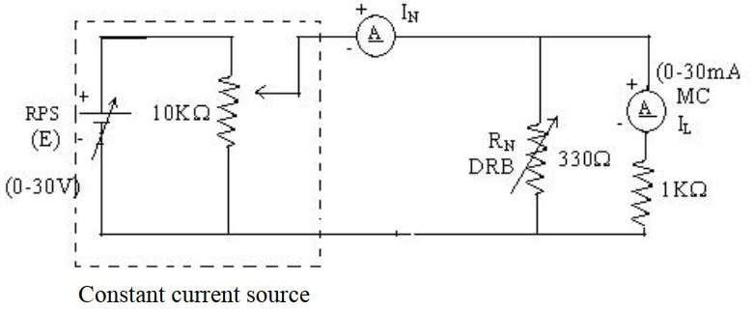
Norton’s equivalent circuit

Norton’s Practical Values
 | E (volts) | IN (mA) | Rn  (ohms) | IL (mA)
 |  |  |  | Circuit - I | Equivalent Circuit
Practical Values | 10 10.1 |  | 4.95 | 3.34 | 3.34

Answers of Post Lab Questions

1. What is Norton's theorem?
Norton's theorem states that any linear bilateral two-terminal electrical network can be replaced by an equivalent circuit consisting of a single current source in parallel with an equivalent resistance. The current source is called Norton current (I_N), and the parallel resistance is called Norton resistance (R_N). The theorem simplifies complex circuits and helps in analyzing load current and voltage easily.

2. What are the applications of Norton's theorem?
Applications of Norton's theorem are:
- It simplifies complex electrical circuits into simple equivalent circuits.
- It is used to calculate load current and load voltage easily.
- It is useful in circuit analysis and troubleshooting.
- It helps in studying the effect of changing load resistance.
- It is used in electronic circuit design and power systems.
- It reduces lengthy mathematical calculations in network analysis.
- It is commonly used in communication and control systems.

3. What are the theoretical and practical limitations of Norton's theorem?

Theoretical Limitations:
- The theorem is applicable only to linear and bilateral circuits.
- It cannot be directly applied to non-linear devices such as diodes and transistors.
- It is mainly used for two-terminal networks only.
- It is not directly suitable for complex transient circuits without modifications.

Practical Limitations:
- Practical measurements may contain errors due to instrument tolerances.
- Internal resistance of measuring devices affects readings.
- Loose connections and wire resistance may change the results.
- Temperature changes can affect resistor values.
- Practical results may slightly differ from theoretical calculations because of component tolerances.

Circuit Overview
You have three main sections:
Top section (green): Battery B1 (10V) with R1, R2, R3, R4 in a bridge-like arrangement with a current source on the right.
Middle section (red): Battery B2 (10V) with R5, R6, R7 in a similar configuration with another current source.
Bottom section: R9, R8, R10 with a measured load (HM1 - ohmmeter or similar instrument).

Solution Approach
The standard method for solving this multi-loop circuit is Mesh Current Analysis (also called loop current method):
Step 1: Identify Mesh Loops Define independent current loops for each closed path. Based on the circuit, you'd typically define loops around the main rectangular sections. Each loop gets a variable (like I₁, I₂, I₃).
Step 2: Apply KVL to Each Loop For each mesh loop, sum all voltage rises and drops around the closed path and set equal to zero:
- Voltage rises from batteries: positive
- Voltage drops across resistors: negative (in the direction of assumed current)
- For shared resistors between loops, use the net current difference
Step 3: Set Up System of Equations This gives you simultaneous equations. For example, if you have three loops, you get three equations with three unknowns.
Step 4: Solve Simultaneously Use substitution, elimination, or matrix methods to find the mesh currents.
Step 5: Find Branch Currents and Voltages Once you have mesh currents, calculate actual branch currents by combining the appropriate mesh currents. Then use Ohm's Law (V = IR) to find voltage drops.

Key Observations
- Symmetry: The top and middle sections appear structurally similar (both with 10V sources, similar resistor values). This might simplify the math.
- Current sources on the right side would inject known currents that constrain the circuit behavior.
- The bottom section with the ohmmeter measures voltage/resistance across a particular node pair.

